Report :
Assignment 01: installing basic software.
- Installing python
IDLE details :
Python 3.12.1 (v3.12.1:2305ca5144, Dec 7 2023, 17:23:38) [Clang 13.0.0 (clang-1300.0.29.30)] on darwin
Type "help", "copyright", "credits" or "license()" for more information.
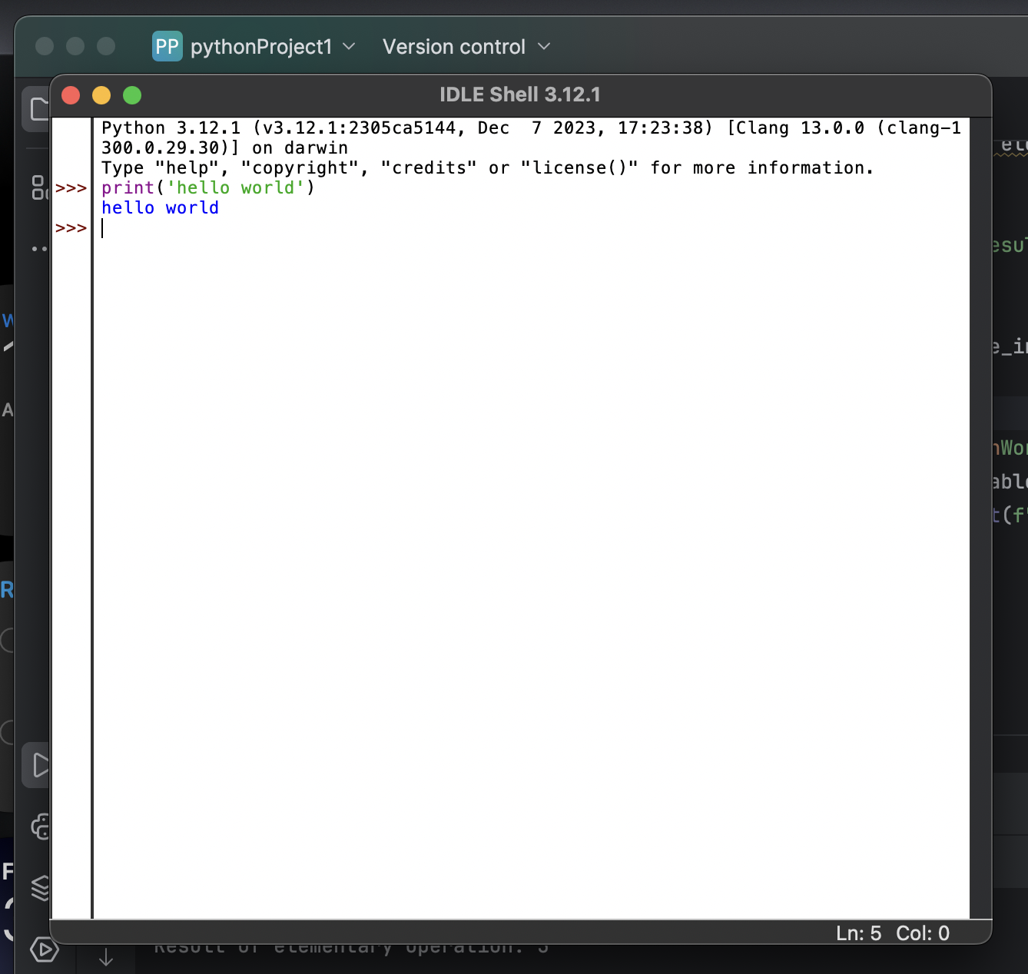
Launched the software in pycharm – a dedicated platform . 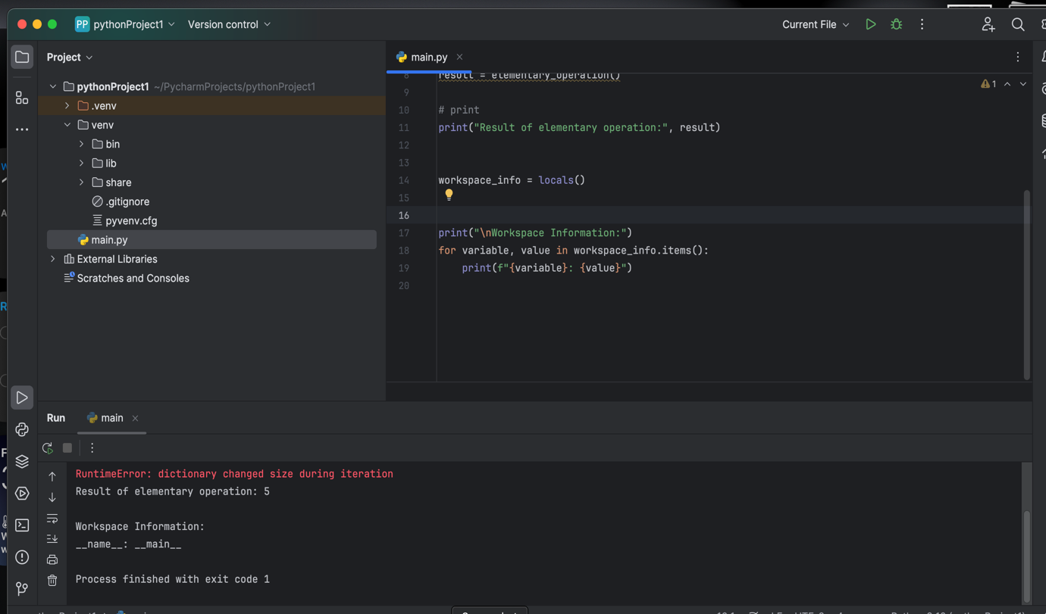

used algo : simple addition algorithm .
code :
# Sample Python Script we have done to make sure everything works

# Elementary Operation/Function to be performed here
def elementary_operation():
return 2 + 3

# elementary operation is to be performed.
result = elementary_operation()

# print
print("Result of elementary operation:", result)

workspace_info = locals()

print("\nWorkspace Information:")
for variable, value in workspace_info.items():
print(f"{variable}: {value}")

results in terminal :
(.venv) ganesh@Ganeshs-Air pythonProject1 % python main.py
Result of elementary operation: 5

Workspace Information:
__name__: __main__
Traceback (most recent call last):
File "/Users/ganesh/PycharmProjects/pythonProject1/main.py", line 18, in <module>
for variable, value in workspace_info.items():
RuntimeError: dictionary changed size during iteration
(.venv) ganesh@Ganeshs-Air pythonProject1 %

- Installing MySQL :
Installed MySQL Workbench and mysql on macOS using the provided link ;

Here we are simply creating a table .
Input data : present , no input data , just a table with some rows, columns .
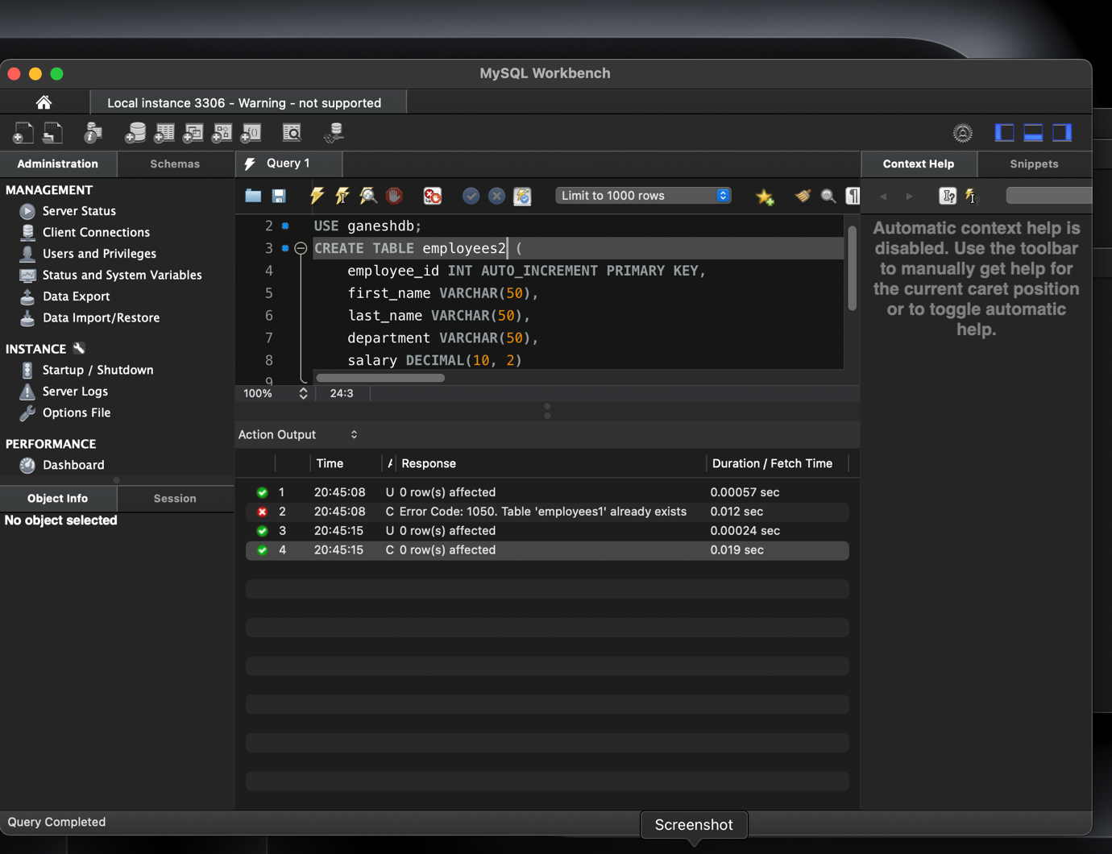
Query 1 :

CREATE DATABASE ganeshdb;
USE ganeshdb;
CREATE TABLE employees1 (
employee_id INT AUTO_INCREMENT PRIMARY KEY,
first_name VARCHAR(50),
last_name VARCHAR(50),
department VARCHAR(50),
salary DECIMAL(10, 2)
);
Output :
Created database
Using ganeshdb;
Created a table ;

Session details :
Connection Details
Name:
Local instance 3306
Host:
localhost
Port:
3306
Login User:
root
Current User:
root@localhost
SSL cipher:
SSL not used
Server
Product:
MySQL Community Server - GPL
Version:
8.3.0
Connector
Version:
C++ 8.3.0
- Hadoop
Installing Hadoop on macOS
- Installed brew
- Installed Hadoop using brew command
- Installed java jdk on mac java 8
- Installed code to shell terminal in vscode
- Launched Hadoop using ‘ code Hadoop env.sh’.
- Uncommented the path of export java and pasted the path of java
- Changed the configuration in core-site.xml files
- Changed the configuration in hdfs-site.xml
- Changed the configuration in mapred-site.xml
- Changed the configuration in yarn-site.xml
- Ran hadoop namenode -format
- Ran ~ start-all.sh
- Then running jps
- Then we proceed to generating and registering keygen .
- ~jps on terminal
- Ran the local host on web browser .
- Then we proceed with change in directories in mac terminal .
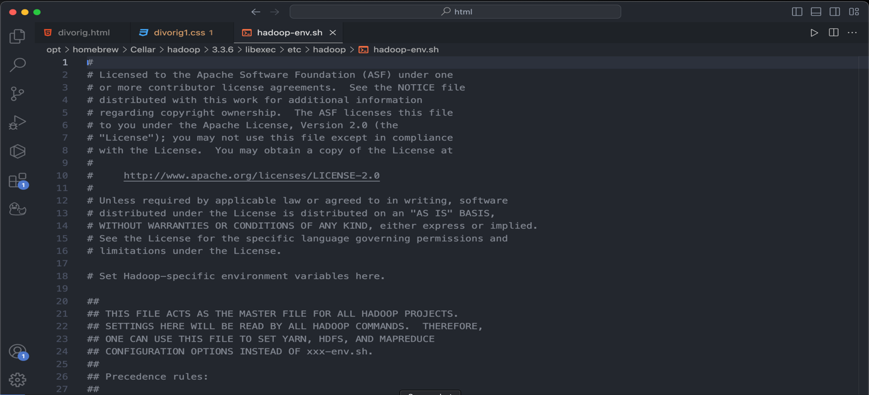

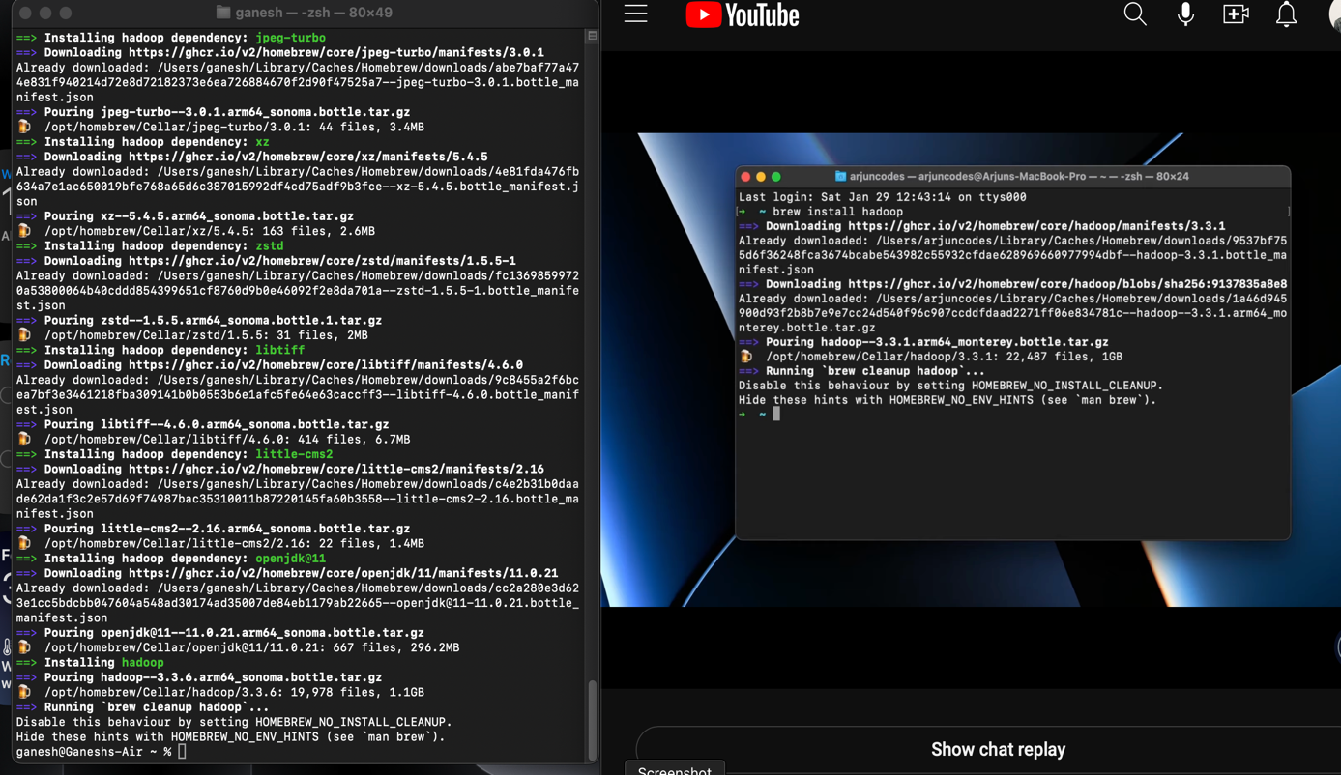
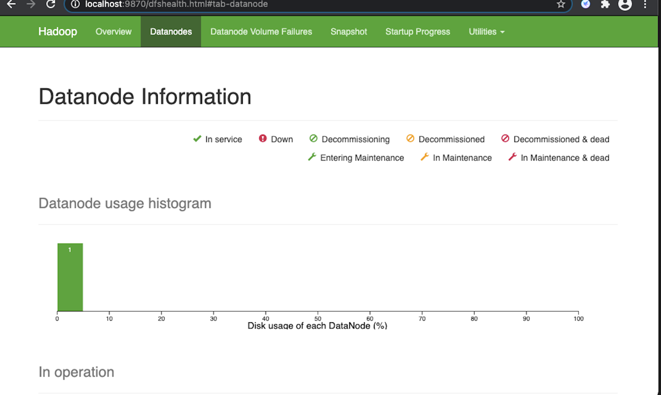

Installing Apache Spark on MacOS .

Procedure:
- I have downloaded Apache spark from the org website and installed the spark .
- Then all the related binaries will be formed in the file .
- Different directories will be available .
- Bin is important here as it contains all the executable commands and shells required for the pyspark to run
- Then in the terminal after following up our apache directory .
- Ls will list all the files in apache .
- 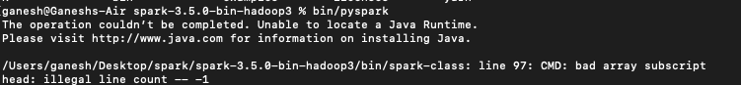
- Then running bin/pyspark will result an error as there is no java installed in my mac
- No java Run time environment: Spark is written on SCALA but it is run on java Virtual Machines .
- Then java is being installed on to my mac.
- Again bin/pyspark is being executed.

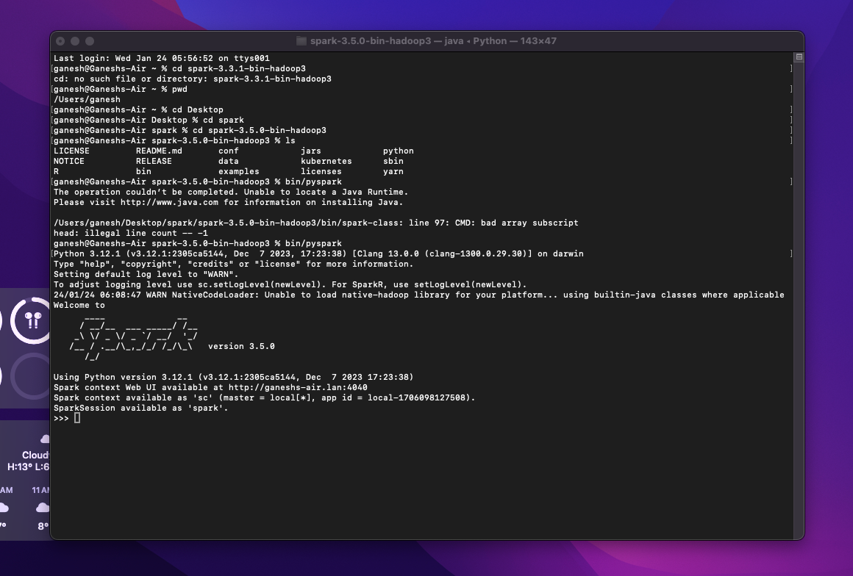
- It says it is using Python version 3.12.1
- And the web page is available at htp://ganeshs-air.lan:4040 where the 4040 is port .
- Viewing it on the browser.
